Project Documentation format
1. Introduction
- Project Title: [Visualization Tool for Electric Vehicle Charge and Range Analysis]
- Team Members:
  - Y. Reddy Sai (Team Leader)
  - Y. Kanakavathi
  - Vanya Damarukanadh
  - Bandari Jagadeesh
  - Shruthi Dnyanoba Sadewad

Project Overview

- Purpose: To solve "range anxiety" by providing an interactive dashboard that visualizes how external factors (temperature, speed, terrain) impact EV battery performance and charging times.
- Features:
  - Dynamic range prediction based on ambient temperature. o Interactive charging curve graphs for various EV models. o Geographic heat maps of charging station infrastructure.
  - User-specific vehicle profile saving.

Architecture
- Frontend: Built with React.js for a responsive SPA (Single Page Application). Uses D3.js and Tableau Embedded API for complex data visualizations.
- Backend: A RESTful API built with Node.js and Express.js to handle user authentication and data fetching from charging network APIs.
- Database: MongoDB (NoSQL) stores user accounts, saved vehicle configurations, and historical trip logs.

Setup Instructions
- Prerequisites: Node.js (v16+), MongoDB Atlas account, and Tableau Desktop (for dashboard authoring).
- Installation:
  - git clone [repository-url]
  - Navigate to /client and /server folders.
  - Run npm install in both directories.
  - Create a .env file in the server directory with MONGODB_URI and API_KEYS.

Folder Structure
- Client: /src/components (UI elements), /src/charts (Visualization logic), /src/pages (Dashboard views).
- Server: /models (Mongoose schemas), /routes (API endpoints), /middleware (Auth logic).

Running the Application
- Frontend: npm start in the client directory (runs on port 3000).
- Backend: npm start or nodemon server.js in the server directory (runs on port 5000).

API Documentation
- GET /api/vehicles: Returns list of supported EV models and battery specs.
- POST /api/analyze: Accepts temperature and speed inputs; returns projected range data.
- GET /api/stations: Fetches nearby charging stations based on coordinates.

Authentication
- Method: JSON Web Tokens (JWT) for secure session management.
- Logic: Users sign up with an email/password; the server issues a token that the frontend stores in local Storage to access protected dashboard features.

User Interface

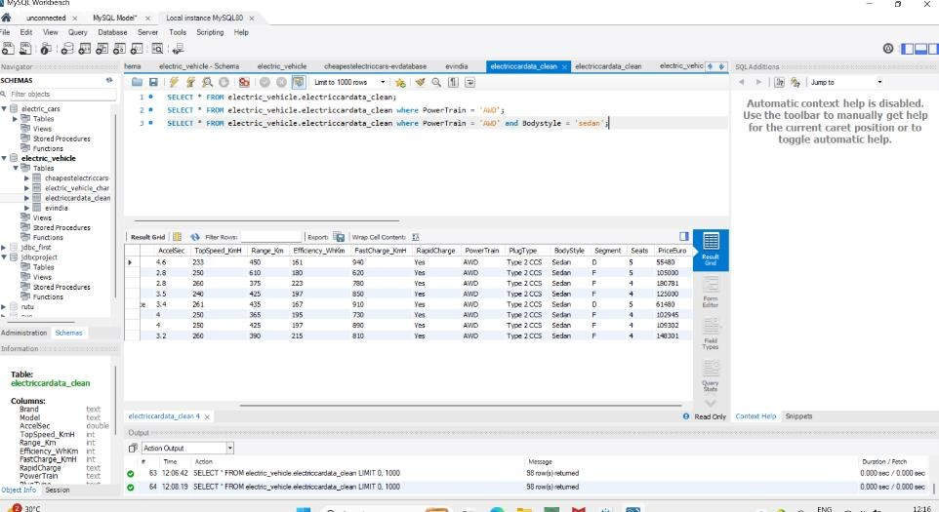
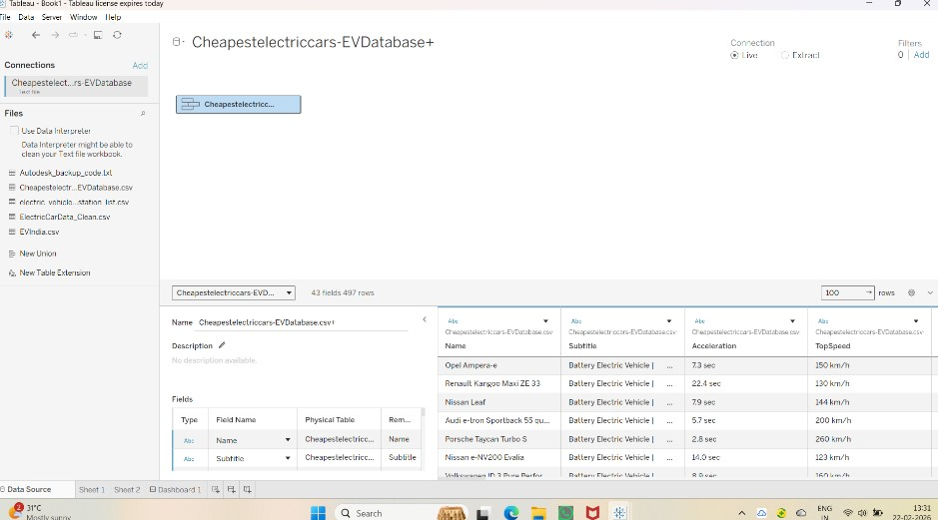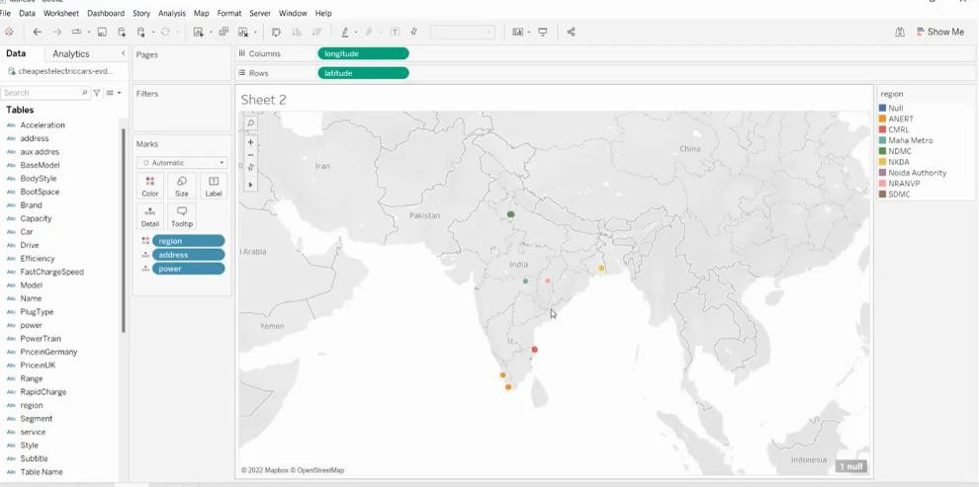

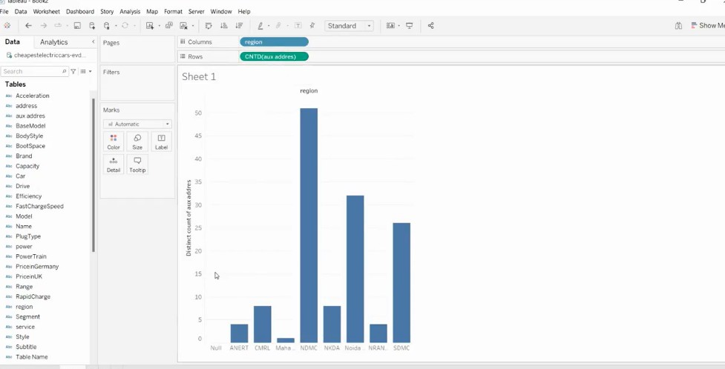
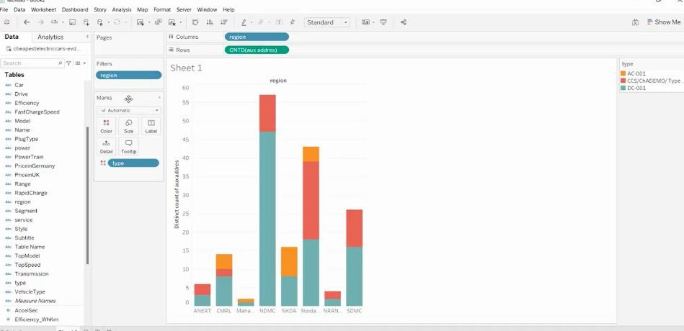

Demo Screenshots

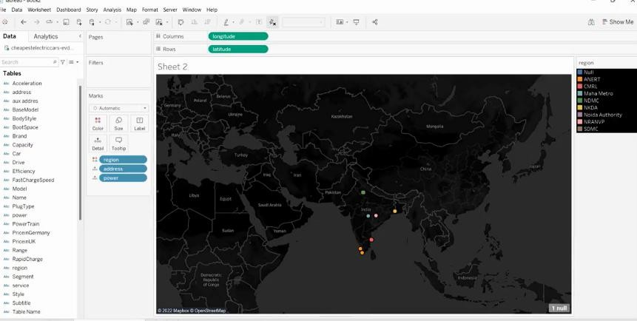

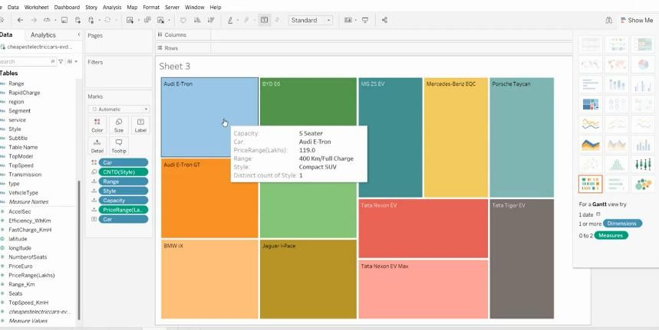

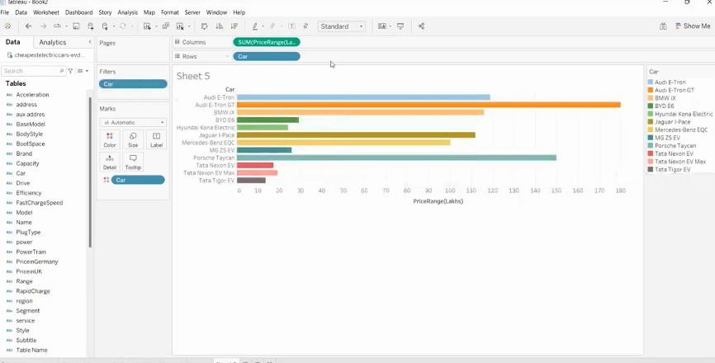

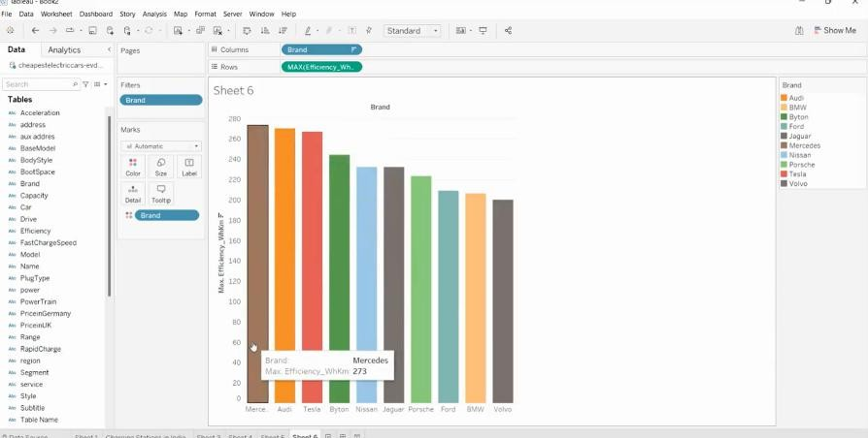

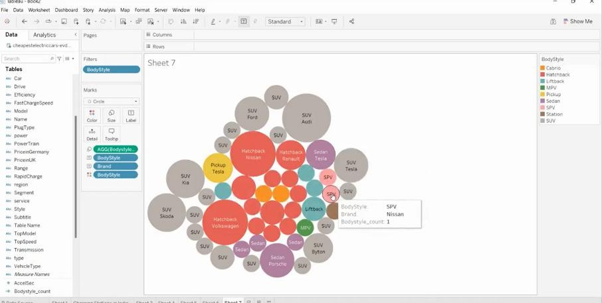

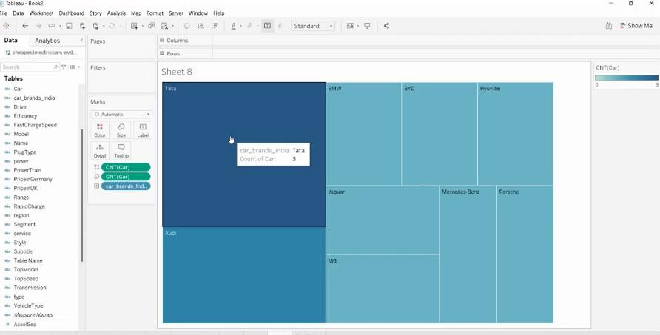

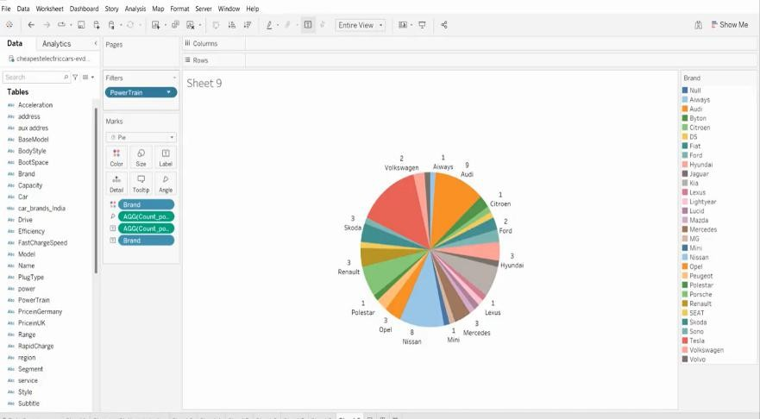

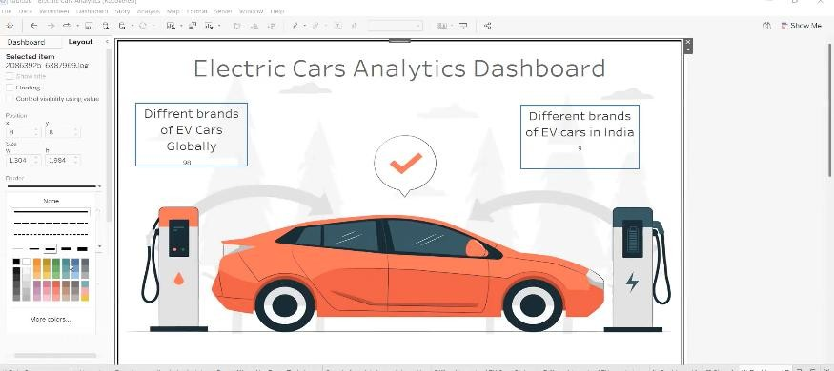

Testing
• Strategy: Unit testing for calculation logic using Jest. API testing using Postman.
Manual UAT (User Acceptance Testing) to ensure visualization accuracy.

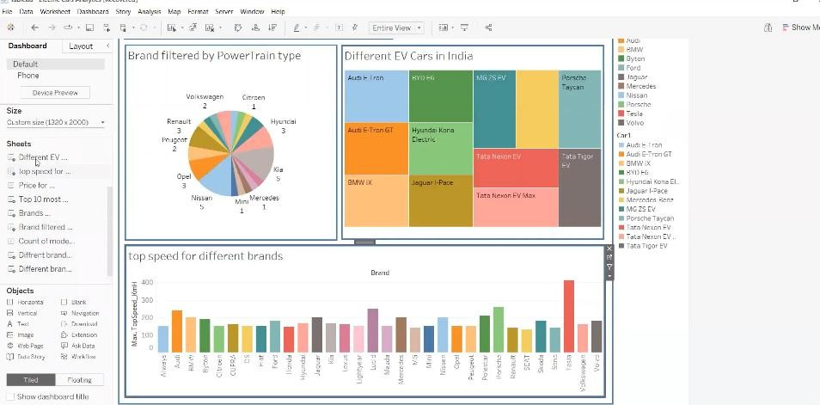

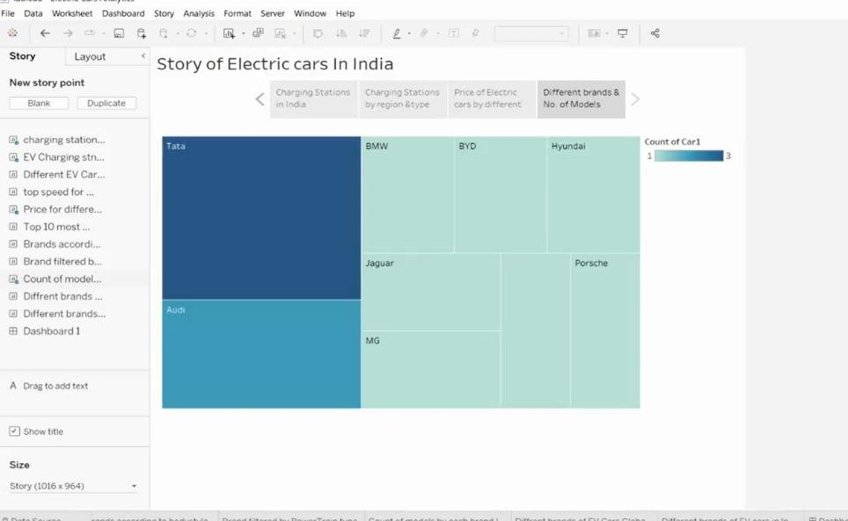

Known Issues
- Slight delay in fetching real-time weather data from external APIs.
- Limited support for legacy EV models (pre-2015) in the database.

Future Enhancements
- Integration with Google Maps for real-time route-based range prediction.
- AI-driven battery health forecasting based on long-term charging habits.

